SIMATS ENGINEERING

ASSESSMENT TOOL 3 - Output Prediction

COURSE NAME: Data Structures COURSE CODE: CSA03
Register Number | 192313041
Name | P.NANDHINI
Assessment Tool Weightage: 35%

COURSE OUTCOME COVERED

CO1: Apply suitable data structures and ADTs for efficient problem solving by analyzing time and space complexity. (BL3, BL4)

Questions: 5 EACH QUESTIONS CARRIES: 5 MARKS Total Marks: 25 Duration: ONE HOUR

S. No. | 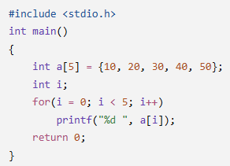  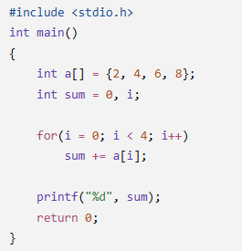  List of Questions
1 | Array Traversal Program
2 | Sum of Array Elements Program

3 | 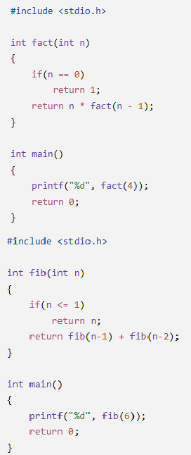  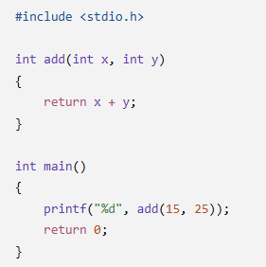  Recursive Factorial Program
4 | Recursive Fibonacci Program
5 | Function as ADT Operation Program

Code of Conduct:

I (Name / Reg No) certify that this submission is my original work and that I have adhered to the guidelines specified for this assessment.
I understand that any violation of academic integrity rules will result in disciplinary action.

Signature of the student:

RUBRICS FOR CALCULATION:

Criteria | Weightage (5 Marks) | Level 4 – Exemplary  (5 Marks) | Level 3 – Proficient  (4 Marks) | Level 2 – Developing  (3 Marks) | Level 1 – Beginning  (1–2 Marks)
Understanding of Program Logic | 1 | Correctly identifies the complete program flow and execution  sequence. | Minor misunderstanding of program flow. | Partial understanding of logic. | Unable to  interpret the program logic.
Trace of  Variables / Function Calls | 1 | Accurately traces all variable values, iterations, and  recursive calls. | Traces most values correctly with minor errors. | Traces some values but misses important steps. | Incorrect or no tracing.
Output Prediction Accuracy | 2 | Output predicted  completely and correctly. | Output mostly correct with minor mistakes. | Output partially correct. | Output  incorrect or missing.
Complexity Interpretation (Time/Space) | 1 | Correctly identifies and justifies complexity where  applicable. | Correct complexity with limited  justification. | Partial understanding of complexity. | Incorrect or no complexity analysis.

1.Array Traversal Program:

#include <stdio.h>

int main()
{
int a[5] = {10, 20, 30, 40, 50};
int i;

for (i = 0; i < 5; i++)
{
printf("%d ", a[i]);
}

return 0;
}

Output:

10 20 30 40 50

Main topic: One-Dimensional Array Using a for Loop in C.

2. Sum of Array Elements Program:

#include <stdio.h>

int main()
{
int a[] = {2, 4, 6, 8};
int sum = 0, i;

for (i = 0; i < 4; i++)
{
sum = sum + a[i];
}

printf("%d", sum);

return 0;
}
Output:

20

Main topic: One-Dimensional Array Sum Using a for Loop in C.

3. Recursive Factorial Program:

#include <stdio.h>

int fact(int n)
{
if (n == 0)
return 1;

return n * fact(n - 1);
}

int main()
{
printf("%d", fact(4));

return 0;
}
Output:

24

Main topic: Recursion in C — Factorial Calculation Using a Recursive Function.

4. Recursive Fibonacci Program:

#include <stdio.h>

int fib(int n)
{
if (n <= 1)
return n;

return fib(n - 1) + fib(n - 2);
}

int main()
{
printf("%d", fib(6));

return 0;
}
Output:

8

Main topic: Recursion in C — Fibonacci Series Using a Recursive Function.

5. Function as ADT Operation Program

#include <stdio.h>

int add(int x, int y)
{
return x + y;
}

int main()
{
printf("%d", add(15, 25));
return 0;
}
Output:

40

Main topic: Function-Based Addition Operation in C.

